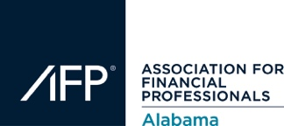

2019 Evolution Education Day Agenda
Birmingham, AL I December 3, 2019

7:30 AM - 7:45 AM

Registration
8:00 AM
Opening Remarks
8:15 AM - 9:15 AM
Scott Jones and Adam Griffin, Adams & Reese
Corporate Account Takeovers and Security Procedure Trends and Case Studies

9:30 AM - 10:30 AM

Mike Reynolds, Technology Management Resources, Inc.

Payments… What’s Next, Checkless Lockbox?
10:30 AM - 11:30 AM
Jenny Johnson, ECCHO & Angi Farren, AAP, APRP, UMACHA
Regulation C - What’s New?
Lunch – 11:30 – 12:30
12:30 PM - 1:30 PM
Kevin Olsen, AAP, NCP, APRP, Senior Vice President, vsoft
The Evolution of “The Banking Revolution”

1:45 PM - 2:45 PM
Brian Laverdure, Director, Emerging Payments Education, EPCOR
Emerging Payments Update – The Present and the Future

3:00 PM - 4:00 PM
Sean Carter, NEACH
The organization is not innovating fast enough and it is not your fault!

